**On Leiden fridge crashes & mixture lost – Ik Kyeong Jin 28/04/2021**

Problem

1. Fridge crashed 3 times, only when we put in the RF probe.

19/03 – 22/03 Blank probe (okay)

24/03 – 30/03 RF probe (crashed)

31/03 – 06/04 RF probe (crashed)

09/04 – 13/04 RF probe (crashed)

16/04 – 19/04 DC probe (okay)

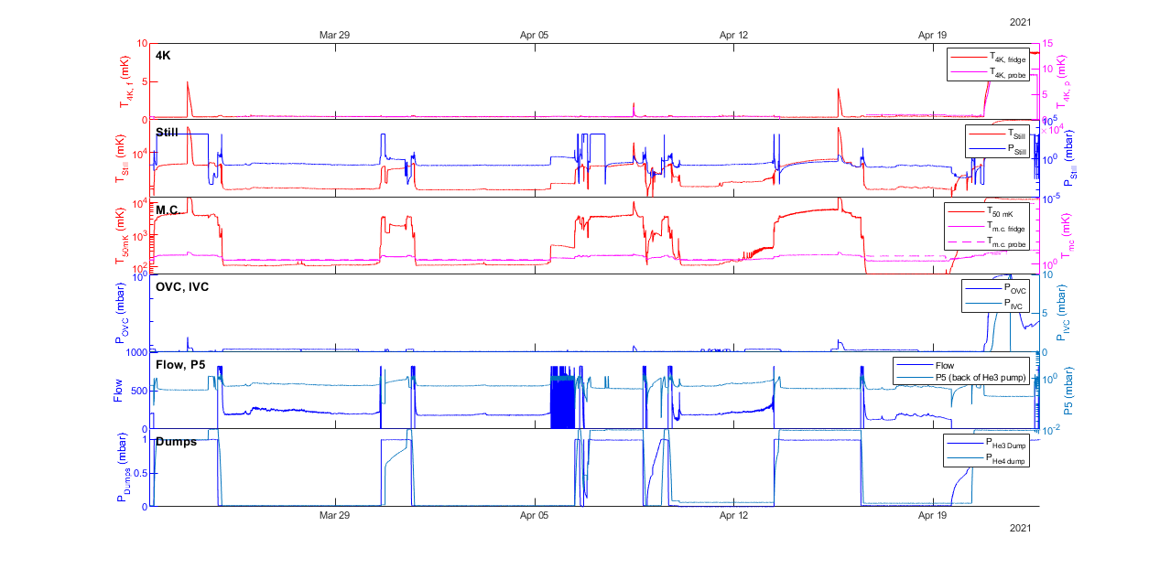

Reason of the crashes

* RF probe introduces too much heat load (flow = 60 ~ 70 on GHS; ideally should be 40)
* Using the DC probe will not crash the fridge. Not verified yet - One who will run the fridge will.

1. We are losing mixtures 5 times faster than the normal.

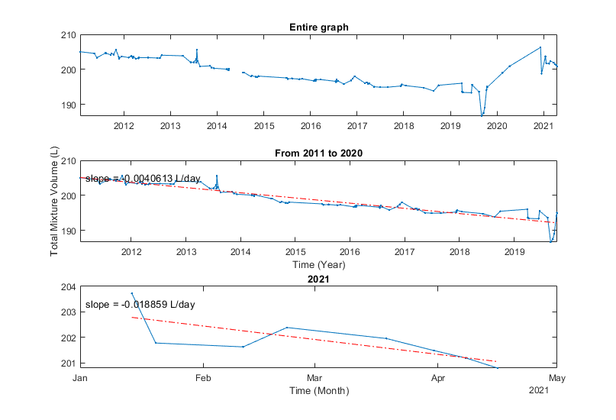

Reason of the recent mixture lost

When we are recovering, we did not pull out all the 4He from the still.

We think that we lost the mixture to the IVC because:

* We had to pump out the IVC after the third condense.

We think that we lost the mixture after finishing the recovery, not during the circulation because:

1. There’s no leak in the circuit.

At 150 K, at still pressure = 1100 mbar, we **leak checked the IVC** by leak checker (measured by P4 gauge) – No leak (4.1e-9 mbar l/s, P2 = 1.9e-3 mbar)

At 170 K, we **leak checked the emergency line to the dump** – No leak (See page 6)

At 283 K, we **leak checked the mixture compressor when it’s running** – No leak (1.5e-6 mbar l/s, P2 = 1.6e-3 mbar)

**High base leak rate at the compressor means that we are gradually losing 3He from the compressor. This looks like the reason why we lost the He3 over the last 10 years.**

1. You can see that the still is full after finishing the recovery (discontinuity is when I pumped out the still manually)











1. Calculation shows that the still will go up to 200 bar IF the gas did not escape to somewhere.



Emergency valve must have worked – but looks like we also lost some mixtures to the IVC.

**Good news is that in this case we lost 4He, not 3He.**

A few minor points:

Pressure increase in IVC is not directly measurable.

Details:

Mixture dump lost: 146.67 L * 6 mbar / 1013 mbar = 0.87 L

IVC:

I assumed that the green part is IVC. Got the dimensions from the figure by the gas cabinet.

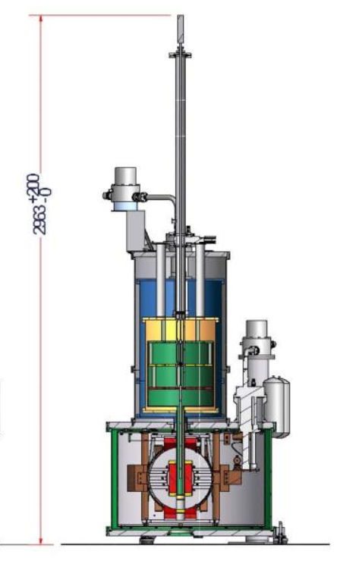

IVC volume = pi*r1^2*h1 + pi*r2^2*h2 = 3.14 * 20 cm *20 cm * 36 cm + 3.14 * 2 cm * 2 cm * 55 cm= 45.9 L

Expected_IVC_Pressure_increase = 6 mbar * 0.87 L/45.9 L = 0.11 mbar at RT.

At 4 K: 0.11*4/300 = 1.5e-3 mbar. We lost the mixture by recovering 5 times.

* Expected_IVC_Pressure_increase = 3e-4 mbar/recovery

See if P6 dump to still is leaking through the emergency valve: Not leaking.

Details:

We opened M2 at 12:49. No discontinuities in still P.



He3 pump leak?

Apr 25th, 18:46 Start pumping out the compressor & still.

Apr 25th, 19:31 Lost mixtures in P5?



BUT when we turn off the pump, wait for a while, and pump again: we got the mixture pressure back to 1.133 bar. 🡪 We don’t exactly understand, but we are not losing mixtures through the pump.