QEDmeas Installation and Usage Instructions

Installation:

To use the latest version of the QEDmeas Labview software, you must first install the version control software that ensures you are using the most up-to-date version.

- Double click the TortoiseSVN installation executable located in the N:\Software\TortoiseSVN folder on the QED server. (Here I have assumed you’ve mapped the server to drive N)

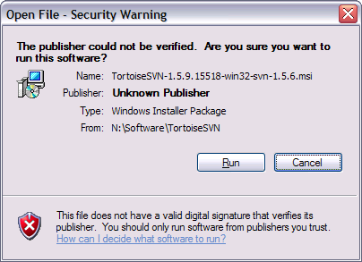

- You should see the above security warning pop up, click Run.

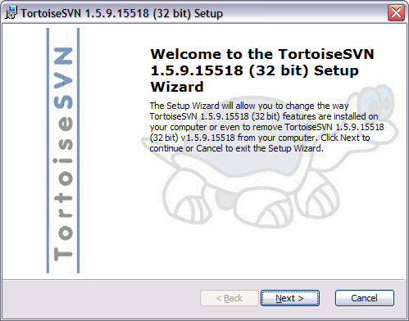

- Click Next once the installation wizard pops up. Accept the license agreement, and click Next again.

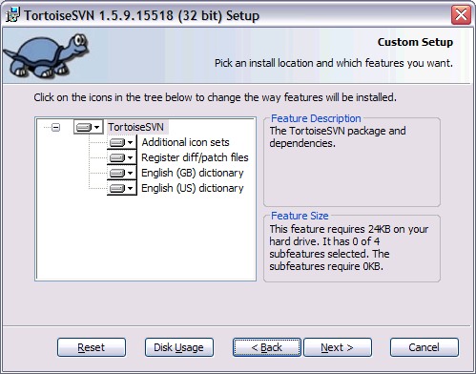

- Install the default features – make no changes and click Next.
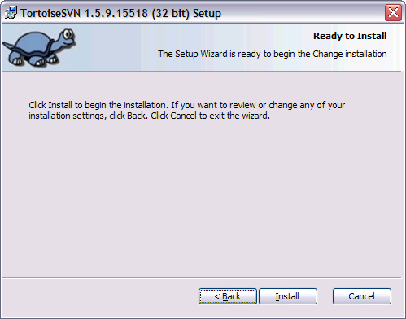

- Click Install to install the SVN software. Once it is finished, click Finish. The software will ask you if you want to restart your computer, you will need to restart in order to use the TortoiseSVN client.
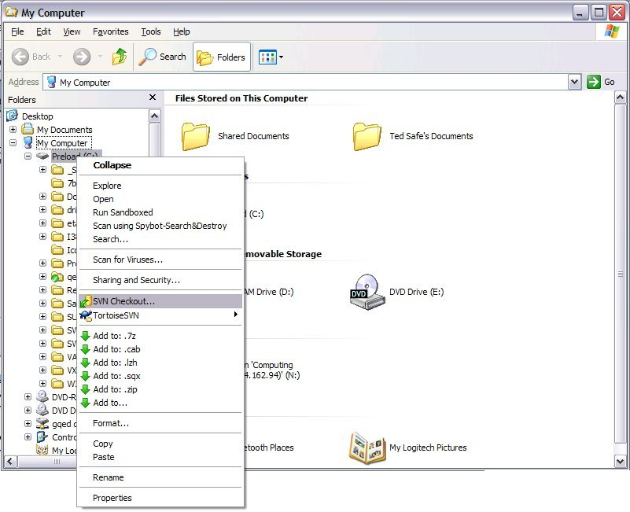

- Once your computer has been restarted, open windows explorer. Right click on your data drive (usually set to D:), and select SVN Checkout… This will install a link to the QEDmeas software on the server.

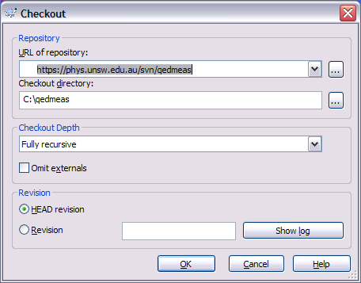

- In the Checkout window, type https://phys.unsw.edu.au/svn/qedmeas into the “URL of repository” field. Leave everything else the same, and click OK.

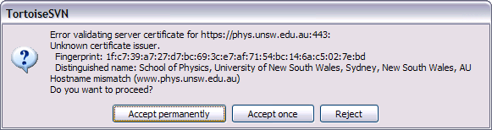

- You will see the above certificate error, choose Accept Permanently. The client will then ask you for your user name and password. If you have a user name and password for the phys.unsw server, you can enter it here. If you do not have access to the phys.unsw server, you will need to obtain access from Christain or David or ask someone with access to enter their password for you.

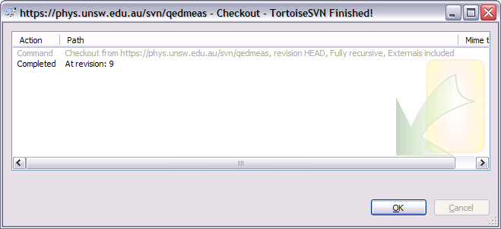

- You should see a window pop-up that will list files that are being loaded from the qedmeas repository on the server to your computer. Click OK.

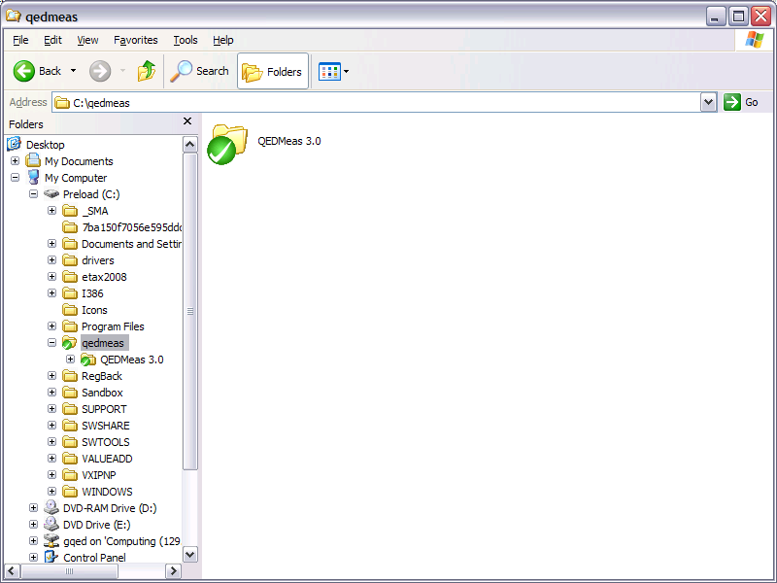

- You should now have a folder called qedmeas in your data folder, and inside will be the latest version of the QEDmeas Labview control software. Use this software to run your measurements.
SVN Usage:

There are three important commands that work with the version control software: SVN Update, SVN Commit… , and SVN Revert.

- SVN Update checks the server to ensure you are using the latest version of the QEDmeas software. If you want to revert to the

- SVN Commit… takes the files that are currently in your qedmeas folder and loads them onto the server, creating a new version of the QEDmeas software. You should ONLY do this if you have written a new Labview VI or you have fixed a major bug in an existing VI. It is important to understand that using SVN Commit… creates a new version on the server that will become the “latest” version that every other user in the group will download.

If you do have a new VI or a bug fix that you wish to upload, only upload the particular file that you have created or fixed, as described in the instructions below. You should also email an explanation of the file you have uploaded to Lap-Hang <laphang@phys.unsw.edu.au> and Ted <tmartin@phys.unsw.edu.au> so that changes to QEDmeas can be properly tracked.

- SVN Revert allows you to revert back to the latest version of the QEDmeas software on the server.

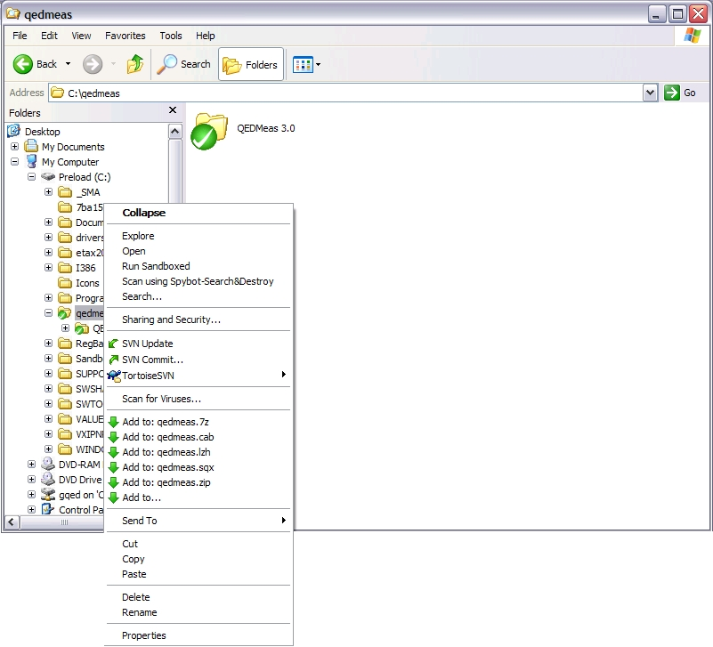

To access either the SVN Update or SVN Commit… commands, right click on the qedmeas folder in windows explorer, and choose either command from the dropdown list.

SVN Update

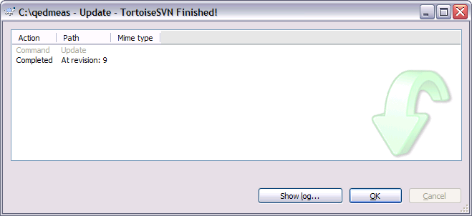

When you use SVN Update, you should see a window open that gives the details of the files moved from the server to your computer. Only files on your computer that differ from those on the server will be overwritten.

Note that during normal usage of the QEDmeas software, you will invariably change some of the files in the qedmeas folder. The changed files will have a red symbol over them instead of a green symbol, as shown below. This does not mean that the file is corrupt, it only means that it differs from the QEDmeas version on the server. You can reload the files from the server using SVN Revert at any time.

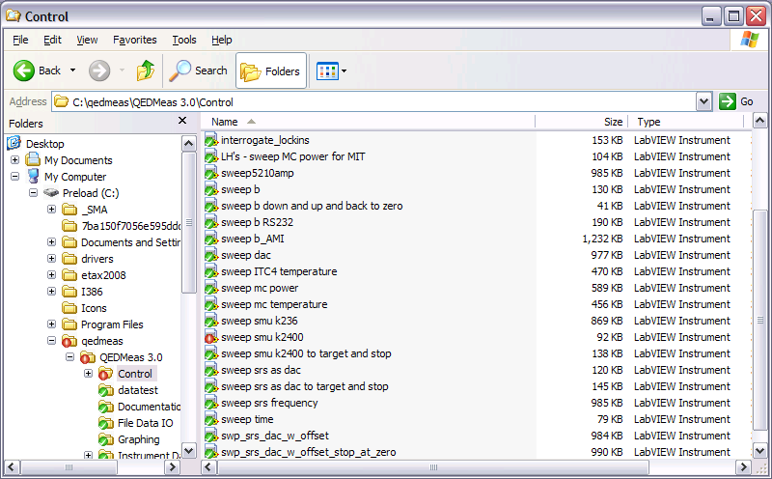
SVN Commit…

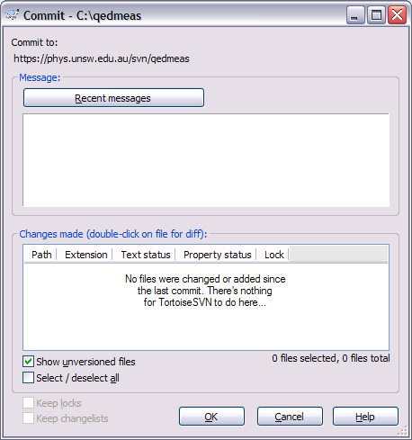

The SVN Commit command will pop up the above window. The window will show any files in your qedmeas folder that do not match those on the server. You can then select the files that you want to commit to the new version on the server by checking the box next to their name. To commit the files to a new version, click OK. Remember that committing any files will create a new version of QEDmeas on the server and OVERWRITE any existing files on the server that you have selected! You should ONLY commit new files that you have created or old files with bugs that you have fixed. Don’t simply commit every file in the list!
SVN Revert

You can use SVN Revert to roll back the QEDmeas software on your computer to the most up-to-date version from the server. This command will overwrite files in your qedmeas folder that have the same names as those on the server.

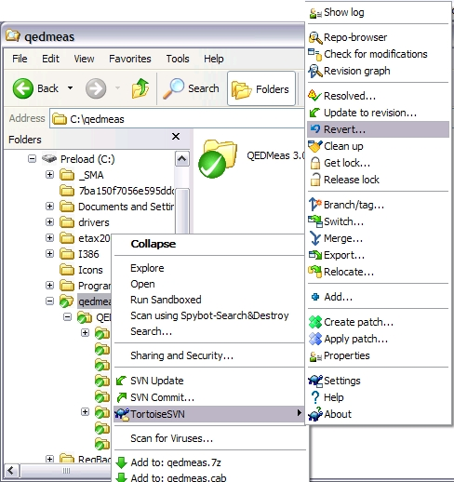

Right click on the qedmeas folder in windows explorer, choose TortoiseSVN and then Revert… from the dropdown lists. If there are any files that do not match those on the server, you will see them in the window that pops up (example below). You can then choose which files you would like to restore from the server, and click OK.



